CTM-I Use Case

Futures CMTA Allocation

Version 0.1

Use Case Name | Futures CMTA Allocation
Actor | One Chicago Firm, Market Ops, Operations, App Support
Pre-conditions /Assumptions | User has Browser and is aware of the http path to the application.  User has successfully logged into the CTM-I application.  User has selected a specific trade to allocate.
Post Conditions | None
Screenshot | 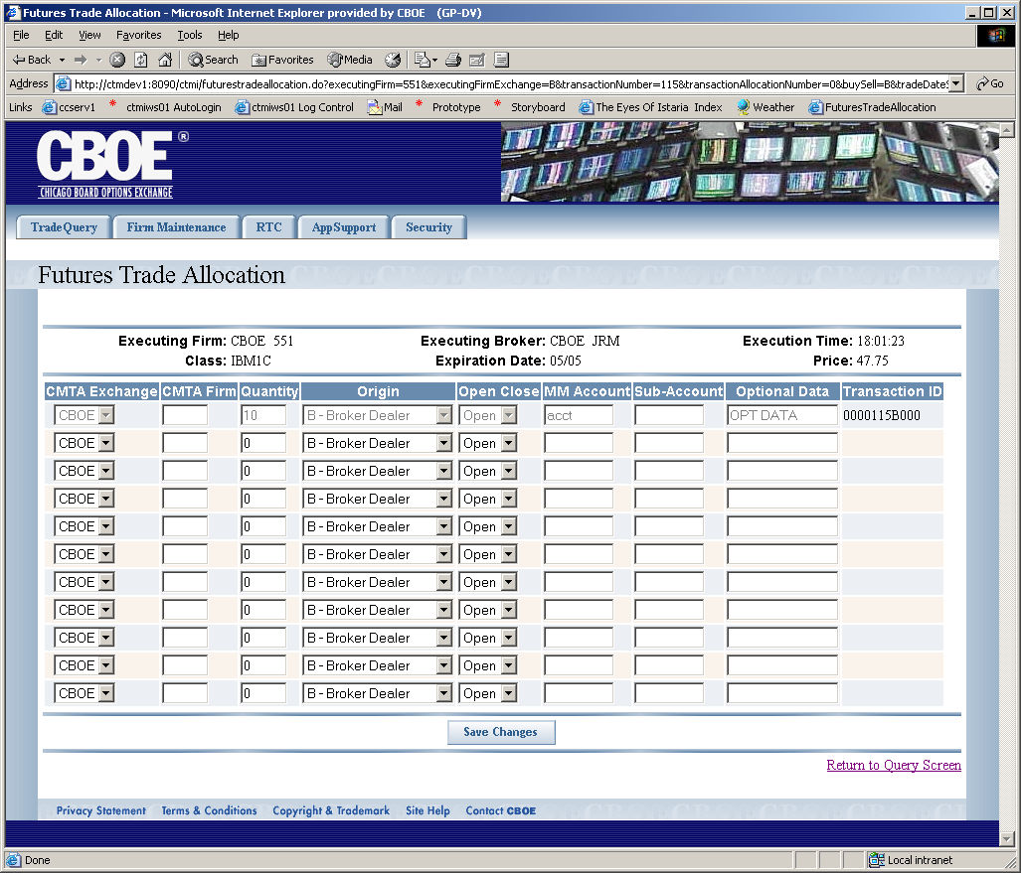
Flow of Events | - Futures CMTA Allocation screen is displayed for the specific trade.  - The following fields are displayed as read only  - Executing Firm – Display firm exchange and number  - Class  - Executing Broker – Display broker exchange and broker  - Expiration Date  - Execution Time  - Price  - A table is displayed for editing the allocations.  - The table contains the following fields  - CMTA Exchange – Limited to “CBOE”, “CME” and “CBOT”  - CTMA Firm  - Quantity – Must be Numeric  - Origin – List of valid origins  - Open/Close – Limited to “Open” and “Close” and blank  - Market Maker Account  - Sub-Account  - Optional Data  - Transaction ID (readonly)  - The first row of the table is the original data from the trade.  - The quantity field should represent the amount that has not been allocated. The number should dynamically update as an allocation row is entered.  - An additional 10 rows should show in the table. These rows are editable rows for entering allocations.  - User presses the “Save Changes” button  - Allocations are sent to CTM-R to save  - Saved changes are shown on the screen in a readonly mode
Alternative Path | At any point the user can click on a link to return them to the Futures Trade Query. The last criteria the user used to search will be used and the search results displayed for the search. If any allocation has not been saved, the user will be warned that their changes will be lost if they continue, with an option to cancel the link.

